Analysis of Factors Influencing Customer Satisfaction; A Case Study of Eyewear Company

Student Name:

Student ID:

**Table of Contents**

1.0 INTRODUCTION 2

2.0 LITERATURE REVIEW 5

3.0 DATA ANALYSIS METHOD 7

4.0 DATA ANALYSIS AND INTERPRETATION 9

4.1 Descriptive Statistics 9

4.2 Correlation Analysis 12

4.3 Multiple Linear Regression Modelling 13

5.0 DISCUSSION, LIMITATION AND CONCLUSION 16

6.0 REFERENCES 18

**EXCUTIVE SUMMARY**

Customer satisfaction is a significant factor of consideration to many companies because it directly determines the growth and profitability of a company. Eyewear industry is experiencing a continuous growth in the market share due to increasing demand for eyewear products. However, the industry is also facing a dip in sales due to some factors such as poor lens or incorrect orders given to customers. VisionEcoWear is an eyewear company that designs minimalistic eyewear and the purpose of this study is to evaluate ways of attracting customers through partnerships with other brands to achieve customer satisfaction. The customer satisfaction survey data was analyzed in SPSS. The multiple linear regression results showed that purchase frequency (β=0.21, p<0.05), sustainability (β=0.24, p<0.05), user experience (β=0.17, p<0.05), product quality (β=0.44, p<0.05) and price (β=0.16, p<0.05). Clearly, purchase frequency, sustainability, user experience, product quality and price are positively related to customer satisfaction and they are significant at predicting it. I recommend VisionEcoWear to consider these factors in implementing their decisions to improve customer satisfaction. Also, I recommend a large sample size to be used for future study to avoid issues of sample size error.

# INTRODUCTION

The modern world business environment is highly competitive due to several factors such as increased accessibility to information by consumers due to technological advancement hence the need for companies to be more creative and focused on attracting customers to cope up with the competition (Tallman et al. 2018). This is where data analytics come in handy because it provides significant insights that help managerial decision makers make well informed decisions to help a company grow (Ahmed et al. 2017). In this case study I will be analyzing a customer satisfaction data on VisionEcoWear, which is an eyewear company. Eyewear industry deals with spectacles, contact lenses, sunglasses and other eyewear products and it was approximated to be worth USD170 billion in 2022 and it is predicted that it will be worth USD 323.8 billion by 2030 (Smith, 2022). There has been market growth in this industry due to the increasing rate of complications associated with vision, increasing need for vision correction, increasing trend in online shopping as well as disposable income and then the increasing trend of fashion popularity which has consequently increased demand for branded eyewear products (Shatskaya et al. 2015). Despite these factors, the industry has been facing challenges. For instance, there has been decrease in sale of eyewear products especially from the ecommerce sector. The dip in sales is expected not unless the cataloging system is optimized (Vitadello, 2018). This is whereby there having a growing trend in which the ordered eyewear products were not correct. The incorrect eyewear products might be due to a number of problems such as having wrong treatment of lens, eyeglasses not fitting the customer properly. There are also other challenges such as changing lens and the new lens might be expensive to the customer, worsening eye conditions making it necessary for customers to buy new updated lens or glasses and this might be expensive as well (Vitadello, 2018). Other problems can be loose frames, scratching the glasses, blurriness, headaches and stretched frames.

The main problem is maintaining and improving customer satisfaction because failing to get customers satisfied then there is high chances of having a significant drop in sales and profitability of the company. For instance, if the VisionEcoWear customers are not satisfied for instance due to faulty eyewear products, poor customer service or unreasonable prices, then the company is expected to lose customers, make losses and even become bankrupt. Therefore, a company understanding its customers is a vital factor in any business because it will get to know which factors do customers like and dislike. As a result, the purpose of this study is to analyze customer satisfaction survey data of VisionEcoWear company to determine which factors are significant at attracting new customers through partnership with other brands. Research questions are;

1. How well do User Experience, Purchase frequency, Sustainability, Product quality and Price predict customer’s satisfaction?
2. Which is the best predictor of customer satisfaction?

# 2.0 LITERATURE REVIEW

This literature review will be focused on brand alliances as a way of trying to attract new customers to achieve the ultimate goal of customer satisfaction. One main purpose of brand name is to provide customers with information about quality of the product meaning that absence of brand name leads to absence of information about a product. An example of a cause-related marketing campaign is a cause-brand alliance, in which a brand endorses a cause in exchange for a customer buying a product linked to the brand. Past literatures have indicated that the attitude customers have towards a brand-brand alliance can significantly determine their behavioral purchase intentions (Arnett et al., 2010), brand equity as well as attitudes towards each partner brand (Washburn et al., 2000). Because of the context in which one brand is displayed alongside the other, according to Simonin and Ruth (1998), consumers incorporate knowledge about the two partnering brands when creating opinions about the brands. Therefore, consumers' opinions of a brand-brand alliance have a direct impact on their opinions of the partnering brands. Lafferty et al. (2004) discovered that cause-brand alliance attitude influenced post-brand attitude when considering situations involving cause-brand alliances between a nonprofit organization and a brand of soup or bottled water.

Further research has revealed that consumers react differently to cause-brand alliances that use high involvement items compared to low involvement products (Baghi et al., 2010), and they are more likely to take part in the alliance (i.e., make a purchase) with a high involvement product (Strahilevitz and Myers, 1998). According to attribution theory, consumers frequently discover a justification for a brand's affiliation with a cause when developing their cause-brand alliance views. In the context of a cause-brand alliance, a consumer may ascribe a brand's involvement (i.e., pro-social conduct) to internal (i.e., the brand is altruistic and wants to support the cause) and/or external (i.e., the brand is under pressure to win over the public and boost profits) factors. Customers will see the cause-brand alliance (i.e., the helpful activity) and the brand (i.e., the helper) more favorably if they believe the partnership was created for altruistic rather than profit-based reasons.

When the reasons are pertinent to the consumers' lives and experiences, cause-related marketing campaigns can successfully raise consumers' intention to purchase the items under the campaigns (Gupta and Pirsch, 2006). Participation in a cause may affect how one feels about a cause-brand alliance. According to the meaning transfer theory, if a person is more engaged with a cause, they will have more positive connections with the cause, which may be transferred to their feelings about the cause-brand alliance (McCracken, 1986). Trimble and Rifon (2006) showed that consumers had a higher positive opinion of the cause-brand alliance when they had a high level of personal involvement with the cause.

# 3.0 DATA ANALYSIS METHOD

Quantitative, qualitative and mixed-method designs are the three research designs used in most studies (Rutberg, 2018). Quantitative design is whereby numerical data is collected and used for the purpose of research while for qualitative design, non-numerical data or nominal data is collected for research purpose (Rutberg, 2018). A mixed-method design is a study that has used both qualitative and quantitative design. In this case study, the study is quantitative because it entailed numerical data that was analyzed in IBM SPSS 26.

The first analysis on the data set was descriptive statistics. This was done to gain a summary understanding of the data set’s variables. Means and standard deviations for of variable was recorded in order to determine the degree of variation or fluctuation of the Likert scale responses from the mean response value (Mishra et al. 2019). Other descriptive summary measures recorded were Kurtosis and skewness which were used to determine the distributions of the variables (Mishra et al. 2019). Kurtosis is used to show how peak is a distribution of a given variable while skewness indicates whether the variable has large tails on the left or right side. Large tails on the right side shows the distribution is skewed to the right while large tails on the left side shows the distribution is distributed to the left. Another important descriptive statistics measure that the study recorded was Shapiro-Wilk p-value. Shapiro-Wilk is a test used to determine if a variable is normally distributed or not (Aslam, 2021). In this test, the null hypothesis is that a variable is normally distributed while alternative hypothesis is that the variable is not normally distributed. To make decision rule, a p-value less than 0.05 leads to rejection of null hypothesis implying the variable is normally distributed (Aslam, 2021). To visualize the distributions of the variables, histogram plots were other descriptive summary statistics that the study analyzed to confirm normality of the variables as depicted by Shapiro-Wilk test.

After gaining a deeper understanding of the variables, correlation analysis was then performed on the data sets. Pearson’s correlation is used to determine the degree of association between two variables (Schober et al. 2018). The coefficient ranges between -1 and 1 showing that two variables can be negatively or positively correlated (Schober et al. 2018). In this case study, correlation analysis will be carried out on the variables User experience, Purchase frequency, Sustainability, Product quality, Price and Customer satisfaction to determine how each of these variables are related to each other.

Regression analysis was then performed on the data set to determine which factors are significant at predicting customer satisfaction. The dependent variable was Customer satisfaction while the independent variables were User experience, Purchase frequency, Sustainability, Product quality and Price. Before performing regression analysis, the correlation analysis above was used as a variable-selection criterion. In regression modelling, independent variables are not supposed to have high degree of correlation with each other. In case two independent variables were highly correlated (r>0.7 or r>-0.7), then one variable is dropped and the other one is included in the model (Shrestha, 2020). This helps to reduce multicollinearity effect (Shrestha, 2020). However, a strong association between dependent and independent variable has no problem. The regression modelling was used to determine which of the independent variables were significant and not significant at predicting customer satisfaction.

# 4.0 DATA ANALYSIS AND INTERPRETATION

## 4.1 Descriptive Statistics

*Table 1: Descriptive Statistics*

|  |  |  |  |  |  |
| --- | --- | --- | --- | --- | --- |
|  | Mean | Std.Dev | Skewness | Kurtosis | Shapiro-Wilk (p-value) |
| Customer Satisfaction | 5.20 | 1.26 | -0.90 | 0.55 | 0.00 |
| Purchase frequency | 4.05 | 1.08 | -0.02 | -0.28 | 0.00 |
| User experience | 5.77 | 1.21 | -1.43 | 2.92 | 0.00 |
| Sustainability | 5.37 | 0.96 | -0.91 | 0.47 | 0.00 |
| Product quality | 3.49 | 0.88 | -0.09 | 1.10 | 0.00 |
| Price | 3.35 | 1.75 | -0.34 | -1.70 | 0.00 |

From table 1, customer satisfaction had 5.20 (*SD*= 1.26), Purchase frequency had 4.05 (*SD*=1.08), User experience had 5.77 (*SD*= 1.21), Sustainability had 5.37 (*SD*= 0.96), Product quality had 3.49 (*SD*=0.88) and then Price had 3.35 (*SD*=1.75). The standard deviations were not significantly large in relation to their mean values and this has an implication that there was no significant deviation or fluctuation of the customer satisfaction response values from the mean value. All of the skewness values were negative and this shows that the distribution of our variables slightly skewed to the left. Purchase frequency and Price had negative Kurtosis values indicating that their distributions were too flat while on the other hand, Customer satisfaction, User experience, Sustainability and Product quality had positive Kurtosis values indicating that their distributions were not too flat. The p-value for Shapiro-Wilk test was less than 0.05 for all of the variables implying that all of the variables were normally distributed. The following are visualizations of the variables;

*Figure 1: Histogram showing distribution of Customer satisfaction*

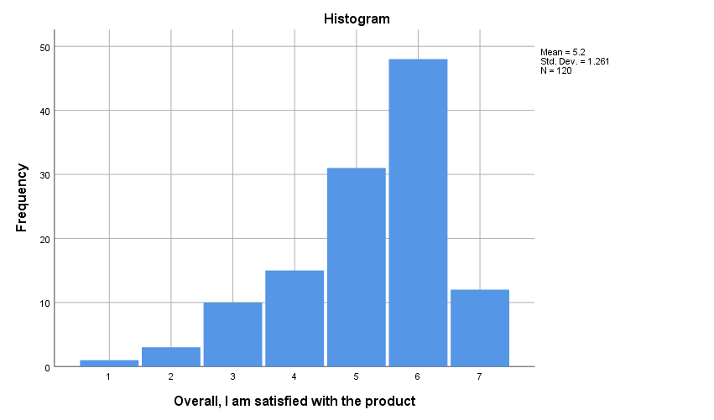

*Figure 2: Histogram showing distribution of Purchase frequency*

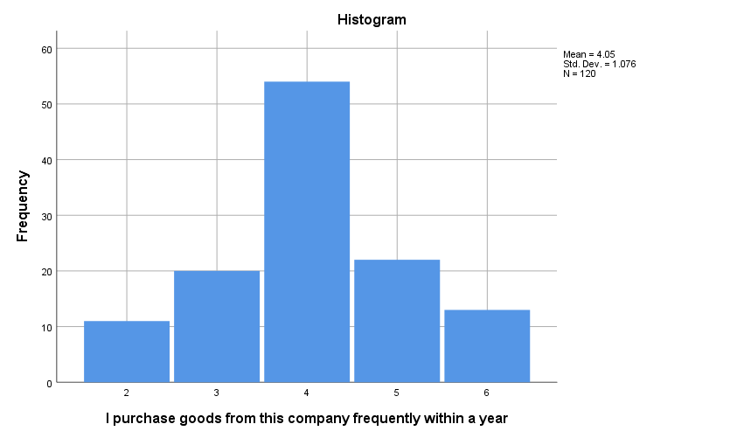

*Figure 3: Histogram showing distribution of Sustainability*

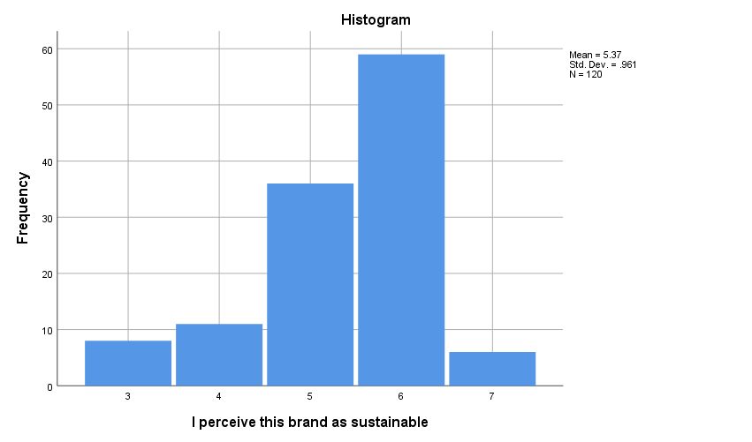

*Figure 4: Histogram showing distribution of User experience*

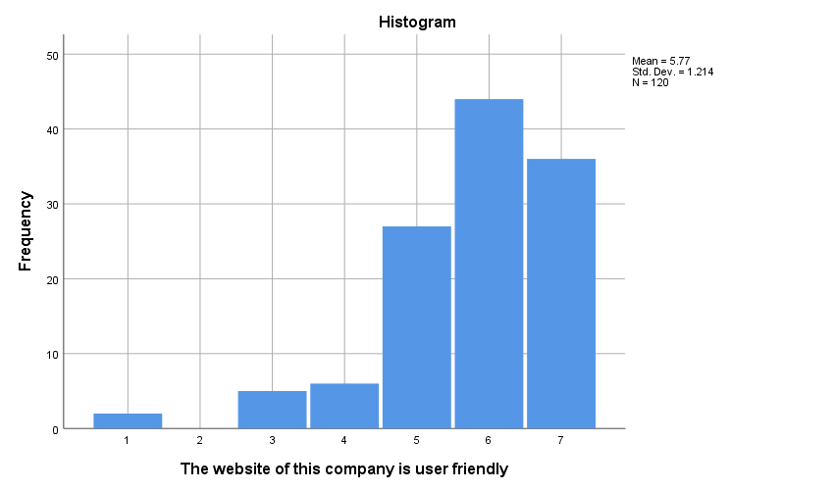

*Figure 5: Histogram showing distribution of Product quality*

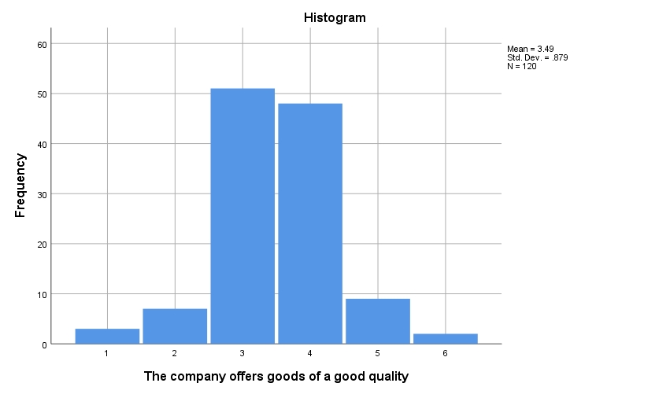

*Figure 6: Histogram showing distribution of Prices*

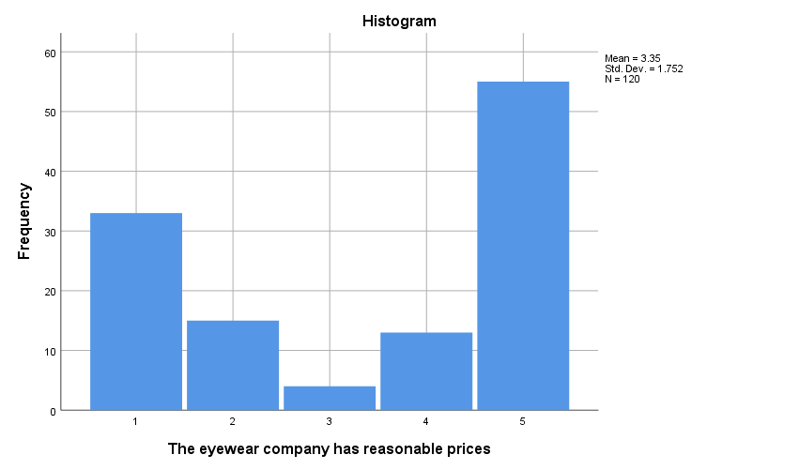

## 4.2 Correlation Analysis

*Table 2: Correlation Matrix*

|  |  |  |  |  |  |  |  |
| --- | --- | --- | --- | --- | --- | --- | --- |
| **Correlations** | | | | | | | |
|  | | Overall, I am satisfied with the product | I purchase goods from this company frequently within a year | I perceive this brand as sustainable | The website of this company is user friendly | The company offers goods of a good quality | The eyewear company has reasonable prices |
| Overall, I am satisfied with the product | Pearson Correlation | 1 | .476** | .501** | .558** | .578** | .565** |
| Sig. (2-tailed) |  | .000 | .000 | .000 | .000 | .000 |
| N | 120 | 120 | 120 | 120 | 120 | 120 |
| I purchase goods from this company frequently within a year | Pearson Correlation | .476** | 1 | .275** | .395** | .258** | .450** |
| Sig. (2-tailed) | .000 |  | .002 | .000 | .004 | .000 |
| N | 120 | 120 | 120 | 120 | 120 | 120 |
| I perceive this brand as sustainable | Pearson Correlation | .501** | .275** | 1 | .484** | .342** | .367** |
| Sig. (2-tailed) | .000 | .002 |  | .000 | .000 | .000 |
| N | 120 | 120 | 120 | 120 | 120 | 120 |
| The website of this company is user friendly | Pearson Correlation | .558** | .395** | .484** | 1 | .439** | .446** |
| Sig. (2-tailed) | .000 | .000 | .000 |  | .000 | .000 |
| N | 120 | 120 | 120 | 120 | 120 | 120 |
| The company offers goods of a good quality | Pearson Correlation | .578** | .258** | .342** | .439** | 1 | .395** |
| Sig. (2-tailed) | .000 | .004 | .000 | .000 |  | .000 |
| N | 120 | 120 | 120 | 120 | 120 | 120 |
| The eyewear company has reasonable prices | Pearson Correlation | .565** | .450** | .367** | .446** | .395** | 1 |
| Sig. (2-tailed) | .000 | .000 | .000 | .000 | .000 |  |
| N | 120 | 120 | 120 | 120 | 120 | 120 |
| **. Correlation is significant at the 0.01 level (2-tailed). | | | | | | | |

The results in table 2 indicated a significant positive but weak relationship between independent variables as well as between dependent variable and independent variables. For instance, Customer satisfaction and Purchase frequency, r (120) = 0.48, p<0.05, Sustainability and Product quality, r (120) = 0.34, p<0.05. The weak relationship independent variables implied that all these variables were to be included in the regression model and there will be no threats of multicollinearity.

## 4.3 Multiple Linear Regression Modelling

*Table 3: Model Summary*

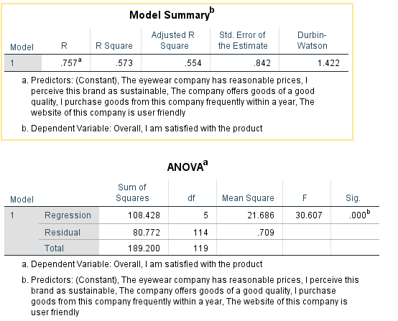

From table 3, R-Squared was 0.573 which implied that the independent variables explained only 57.30% variability in the dependent variable hence the model was averagely good (Sarstedt and Mooi, 2018). *F* (5, 114) = 30.61, p < 0.05 and this F statistic indicated that the model was generally good at fitting the data set since p-value was less than 0.05 (Sarstedt and Mooi, 2018).

*Table 4: Independent variables’ coefficients*

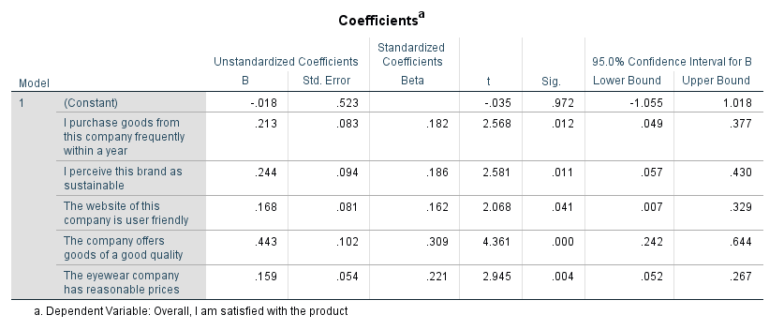

From table 4, Purchase frequency had (β= 0.21, p<0.05) indicating that Purchase frequency is significant at predicting Customer satisfaction and it is also positively related to it (Sarstedt and Mooi, 2018). The positive relationship indicated that an increase in Purchase frequency by 1 will lead to an increase in customer satisfaction by 0.21. Sustainability had (β= 0.24, p<0.05) indicating that Sustainability is significant at predicting Customer satisfaction and it is also positively related to it (Sarstedt and Mooi, 2018). The positive relationship indicated that an increase in Sustainability by 1 will lead to an increase in customer satisfaction by 0.24. User experience had (β= 0.17, p<0.05) indicating that User experience is significant at predicting Customer satisfaction and it is also positively related to it. The positive relationship indicated that an increase in Purchase frequency by 1 will lead to an increase in customer satisfaction by 0.17. Product quality had (β= 0.44, p<0.05) indicating that Product quality is significant at predicting Customer satisfaction and it is also positively related to it (Sarstedt and Mooi, 2018). The positive relationship indicated that an increase in Product quality by 1 will lead to an increase in customer satisfaction by 0.44. Lastly, Price had (β= 0.16, p<0.05) indicating that Price is significant at predicting Customer satisfaction and it is also positively related to it (Sarstedt and Mooi, 2018). The positive relationship indicated that an increase in Price by 1 will lead to an increase in customer satisfaction by 0.16.

# 5.0 DISCUSSION, LIMITATION AND CONCLUSION

The purpose of this study was to determine factors that significantly predicts customer satisfaction after doing brand alliance, simply put, the aim was to determine if brand alliance is significant at attracting customers and in so doing improving customer satisfaction. Regression analysis results indicated that product quality, user experience, price, purchase frequency and sustainability were positively related to customer satisfaction and they were also all significant at predicting customer satisfaction. This agrees with the work done by Gupta and Pirsch (2006), Baghi et al. (2010). This clearly shows that the VisionEcoWear alliance will attract customers improving growth and profitability of the company. The significance of these variables at predicting or explaining customer satisfaction implied that managers of VisionEcoWear as well as other relevant stakeholders can rely on these factors when making projections about customer satisfaction, profits and even when making budgets. All variables being positively related to customer satisfaction means that an increase in these variables will lead to a consequence increase in customer satisfaction. For instance, when there is an increase in product quality such as lens, sunglasses, then customers will be more attracted to purchase the product because customers want to feel the value for their money. Price also had a positive relationship with customer satisfaction and this can be explained by product quality. When quality of product is improved, consequently price will increase and since customers put much emphasis on quality of products in this industry, they will purchase and get satisfied regardless of the price increase. Regarding purchase frequency, if customers frequently purchase a product from a particular shop then implies that these customers are satisfied with the products and services offered by that particular company. This is the reason as to why we have a positive relationship between purchase frequency and customer satisfaction. Concerning sustainability, it means that a given brand or product is reliable and is of good quality definitely it will have a positive relationship with customer satisfaction. Increase in user experience means that a customer had gained a good understanding of the product and when the experience is friendly and less difficult, customers will definitely get satisfied with the product.

The first limitation of this study lies in the data collection process. The customer satisfaction survey was only established in one company, VisionEcoWear and this had poor representation of other customers from various other companies. This means the collected data set was biased and as a result, it had higher chances of leading to biased and unreliable results. Another limitation lies in the sample size whereby the sample size was 120 and this is small because it is not a good representation of the total number of customers in the world in eyewear industry. Due to under-representation of the population, the results risks being biased and unreliable.

To improve reliability and do away with chances of biased results, I suggest that for future studies, a large sample size let say 5000 to be used. I also suggest data to be collected from various industries in order to have inclusivity of customers to reduce biasness. The results clearly indicate that price, product quality, user experience, purchase frequency and sustainability are significant at predicting customer satisfaction and they are also positively related to it. Therefore, I recommend VisionEcoWear Inc. to significantly consider and implement these factors when making decisions on how to increase customer satisfaction.

# 6.0 REFERENCES

Ahmed, E., Yaqoob, I., Hashem, I.A.T., Khan, I., Ahmed, A.I.A., Imran, M. and Vasilakos, A.V., 2017. The role of big data analytics in Internet of Things. *Computer Networks*, *129*, pp.459-471.

Arnette DB, Leverie DA, Wilcox JB. 2010. A longitudinal examination of the effects of retailer-manufacturer brand alliances: The role of perceived fit. Journal of Marketing Management 26(1): 5–27.

Aslam, M., 2021. Analysing Gray Cast Iron Data using a New Shapiro-Wilks test for Normality under Indeterminacy. *International Journal of Cast Metals Research*, *34*(1), pp.1-5. <https://doi.org/10.1080/13640461.2020.1846959>.

Baghi I, Enrico R, Marcello T. 2010. Mental accounting and cause-related marketing strategies. International Review on Public and Nonprofit Marketing 7(2): 145–156.

Gupta S, Pirsch J. 2006. The company-cause-customer fit decision in cause-related marketing. Journal of Consumer Marketing 23(6): 314–26.

Lafferty B, Goldsmith RE, Hult GTM. 2004. The impact of the alliance on the partners: a look at cause– brand alliances. Psychology and Marketing 21(7): 509–31.

McCracken G. 1986. Culture and consumption: a theoretical account of the structure and movement of cultural meaning of consumer goods. Journal of Consumer Research 13: 71–84.

Mishra, P., Pandey, C.M., Singh, U., Gupta, A., Sahu, C. and Keshri, A., 2019. Descriptive statistics and normality tests for statistical data. *Annals of cardiac anaesthesia*, *22*(1), p.67. <https://www.ncbi.nlm.nih.gov/pmc/articles/PMC6350423/>.

Rutberg, S. and Bouikidis, C.D., 2018. Focusing on the fundamentals: A simplistic differentiation between qualitative and quantitative research. *Nephrology Nursing Journal*, *45*(2), pp.209-213. <https://www.proquest.com/openview/af62fd5b0442e59b2729d9fcf7348456/1?pq-origsite=gscholar&cbl=45638>.

Sarstedt, M. and Mooi, E., 2019. Regression analysis. In *A Concise Guide to Market Research* (pp. 209-256). Springer, Berlin, Heidelberg. <https://link.springer.com/chapter/10.1007/978-3-662-56707-4_7>.

Schober, P., Boer, C. and Schwarte, L.A., 2018. Correlation coefficients: appropriate use and interpretation. *Anesthesia & Analgesia*, *126*(5), pp.1763-1768. <https://www.ingentaconnect.com/content/wk/ane/2018/00000126/00000005/art00051>.

Shatskaya, E.Y., Esaulova, I. and Kafyan, K., 2015. International market of eyewear, the place of Italian incredible glasses company and new ways of development for a company. In *Современные тенденции развития теории и практики управления в России и за рубежом* (pp. 179-182). <https://www.elibrary.ru/item.asp?id=25001172>.

Shrestha, N., 2020. Detecting multicollinearity in regression analysis. *American Journal of Applied Mathematics and Statistics*, *8*(2), pp.39-42. <https://www.researchgate.net/profile/Noora-Shrestha/publication/342413955_Detecting_Multicollinearity_in_Regression_Analysis/links/5eff2033458515505087a949/Detecting-Multicollinearity-in-Regression-Analysis.pdf>.

Simonin BL, Ruth JA. 1998. Is a company known by the company it keeps? Assessing the spillover effects of brand alliances on consumer brand attitudes. Journal of Marketing Research 35(1): 30–42.

Smith P., 2022. Value of the global eyewear market from 2022 to 2030. Retrieved from: <https://www.statista.com/statistics/300087/global-eyewear-market-value/#:~:text=The%20global%20eyewear%20market%2C%20which,billion%20U.S.%20dollars%20by%202030>. Last Access [7th, Dec, 2022].

Strahilevitz M, Myers JG. 1998. Donations to charity as purchase incentives: How well they work may depend on what you are trying to sell. Journal of Consumer Research 24(4): 434–446.

Tallman, S., Luo, Y. and Buckley, P.J., 2018. Business models in global competition. *Global Strategy Journal*, *8*(4), pp.517-535. <https://doi.org/10.1002/gsj.1165>.

Trimble CS, Rifon NJ. 2006. Consumer perceptions of compatibility in cause-related marketing messages. International Journal of Nonprofit Voluntary Sector Marketing 11(1): 29–47.

Vitadello, A., 2018. The Future of Eyewear Industry: E-commerce and High-Customized CX. The Case of Warby Parker. <http://157.138.7.91/handle/10579/12458>.

Washburn JH, Till BD, Priluck R. 2000. Co-branding: brand equity and trial effects. Journal of Consumer Marketing 17(7): 591–604.